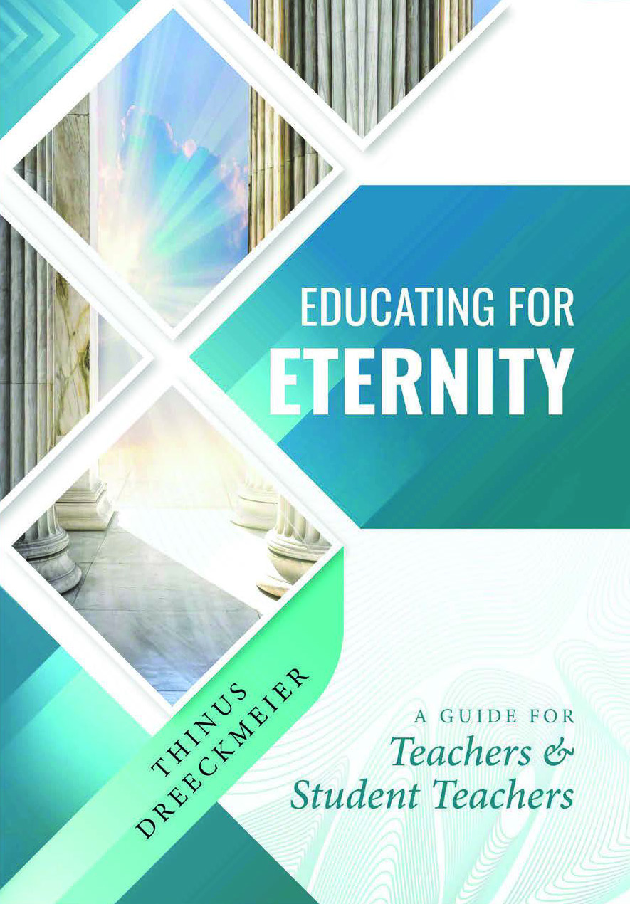

What is God’s eternal plan for education?
Educating for Eternity is meant as a guide for Christian teachers and prospective Christian teachers towards the realisation that education is a powerful instrument in fulfilling God’s divine plan for the ages. Acquiring a basic understanding of God’s plan as revealed in Scripture will challenge them to discover, and hopefully to accept, their part in God’s redemptive plan. In the first part of the book an outline of the contours of God’s eternal plan is presented.
God Himself has written the play and revealed it to us. By His grace we have the privilege to play a part in the production of God’s play. Christian teachers should disclose this plan to the learners through their lives and teachings.
Christ-centred education begins in the heart of the teacher. It begins by teachers accepting God’s invitation to play a role in His story instead of writing their own stories and inviting God to play a part in their stories. It entails discovering and experiencing the motives of God’s eternal heart and then touching the hearts of the learners by sharing it from their hearts.
In the second part of the book a rather comprehensive exposition of the theory and practice of Christ-centred teaching and learning is given. Practical guidelines are given to the teacher of the strategies and methods that could be used to disclose the learning content in such a way that it is connected with God’s divine plan and challenging learners to participate in God’s redemptive plan. Teachers are directed how to change their classrooms into communities of love where practical discipleship of Christ is practised. In this way learners are equipped to become disciples of Christ fulfilling their general and uniquely individual role in God’s eternal plan.
This book may be used as a textbook for the initial training of teachers or for in-service training of Christian teachers. Since Christian parents are accountable to God for the education of their children, the content of this book should also be of interest to them.

Educating for Eternity
Thinus Dreeckmeier
A5 263 p.
ISBN: 987-1-991212-68-9

Order:
Groep7 eShop: R220.00 (Courier costs excluded)
http://groep7-selfpublish-books.co.za/product/educating-for-eternity-thinus-dreeckmeier/

Or
https://groep7-selfpublish-books.co.za/

Direct sales: R180 (Pick-up)
Email: thinus.elsa@gmail.com Cell number: 0832268095
Address: Bateleur Bastion
969 Disselboom Avenue
Wapadrand
0050

E-Book: R 180
www.kobo.com

